DNS Zone Transfers

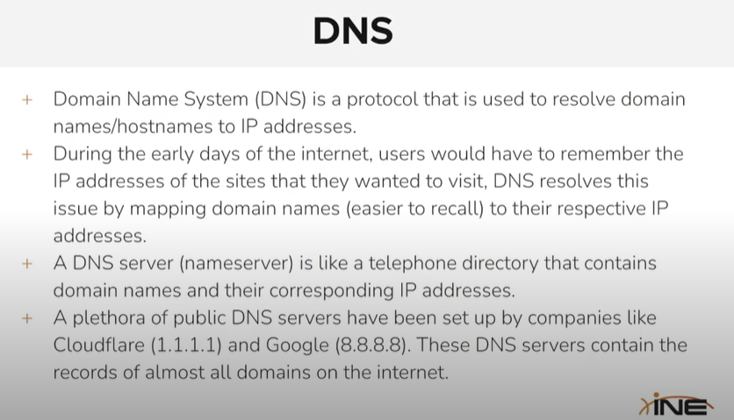

⚠️ Why is it important in hacking / pentesting?
If a DNS server allows zone transfers to anyone, it's a critical misconfiguration.
🔍 Attackers can use this to:
- Enumerate all subdomains
- Map internal infrastructure
- Get IP addresses, email servers, etc.

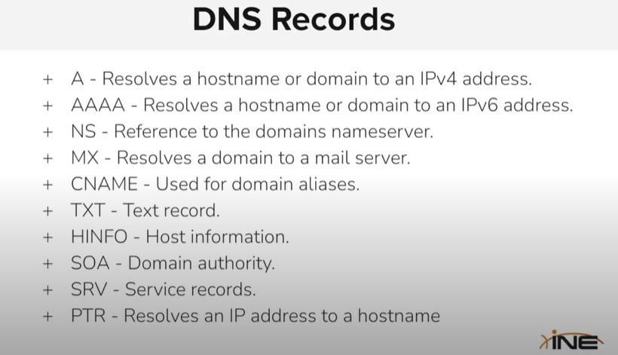
🔹 A Record
➡ Maps a domain name to an IPv4 address.
📌 Example: example.com → 192.168.1.1

🔹 AAAA Record
➡ Maps a domain name to an IPv6 address.
📌 Example: example.com → 2001:0db8::1

🔹 NS Record
➡ Tells which nameserver handles the domain.
📌 Example: example.com → ns1.provider.com

🔹 MX Record
➡ Points the domain to a mail server.
📌 Example: example.com → mail.example.com

🔹 CNAME Record
➡ Makes one domain alias another.
📌 Example: blog.example.com → example.com

🔹 TXT Record
➡ Stores text data — often for verification or SPF/DKIM.
📌 Example: Google site verification

🔹 HINFO Record
➡ Shares basic host info: OS & CPU type.
📌 Example: Linux, x86_64

🔹 SOA Record
➡ Contains admin & authority info about the domain.
📌 Example: Domain owner, refresh times, etc.

🔹 SRV Record
➡ Specifies services (like VoIP, chat, etc.) and where to find them.
📌 Example: Service _sip → sipserver.example.com

🔹 PTR Record
➡ Resolves an IP address back to a domain name (reverse DNS).
📌 Example: 192.168.1.1 → example.com

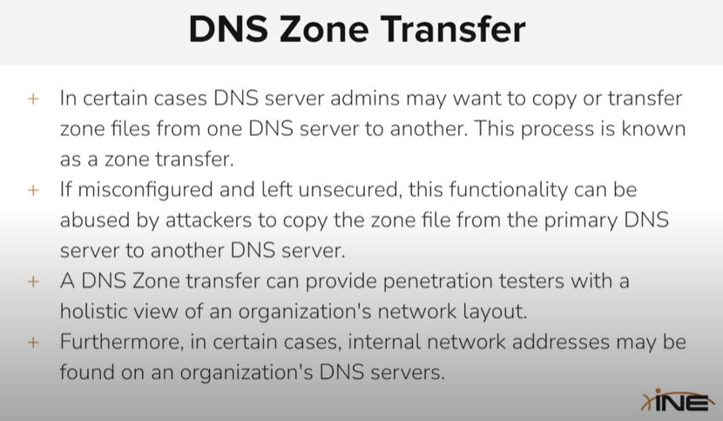

Dnsrecon -d zonetransfer.me

Dnsenum –help

The /etc/hosts file is a local DNS mapping file used by your system to map hostnames to IP addresses — before querying external DNS servers.
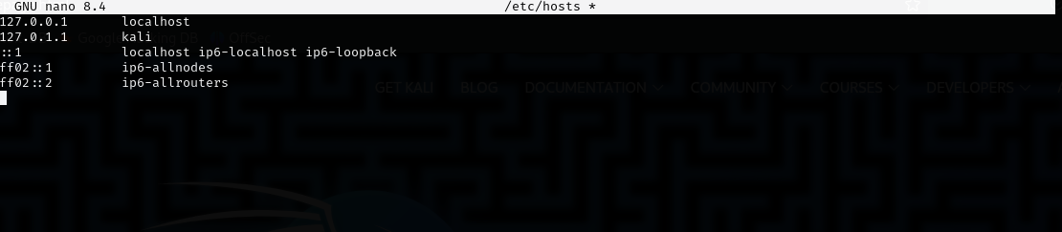
Here we would change the the kali to the umar then check in the browser is it works or not .
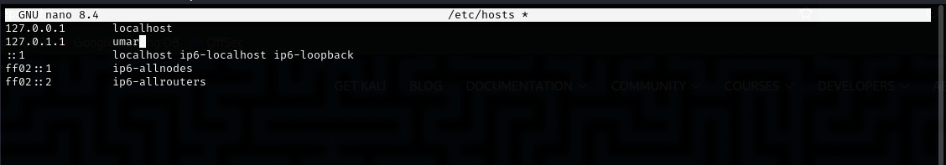

Now write umar in chrome and see what happen :
It will show you the page of the 127.0.1.1.

We can use the
Dnsenum for zonetransfer (it automatically perform the dns zone transfer)
Dnsenum zonetransfer.me
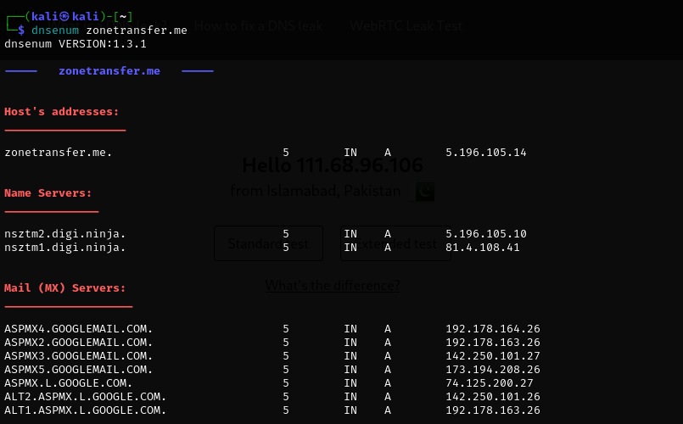

We can also perform zonetransfer with dig.

When you perform a DNS Zone Transfer using tools like dig, dnsenum, or dnsrecon, the records are not stored automatically unless you save them yourself.

📤 The server responds with all DNS records (if it allows it):
- A, AAAA (IP addresses)
- MX (Mail)
- NS (Name servers)
- CNAME (Aliases)
- TXT, SOA, PTR
- Even all subdomains
🕵️ If not secured, this gives an attacker a full map of the domain, which can reveal:
- Hidden subdomains
- Internal servers
- Testing environments
- Email servers

Tool | Tries Zone Transfer Automatically? | Notes
dig | ❌ No | You must manually specify zone transfer with AXFR query. Example:dig @ns1.example.com example.com AXFR
dnsenum | ✅ Yes | Automatically attempts a zone transfer from listed nameservers.
dnsrecon | ✅ Yes (if specified) | It can do it, but you must explicitly request it using -t axfr or -a. Example:dnsrecon -d example.com -t axfr

• dnsenum → ✔️ Auto zone transfer attempt
• dnsrecon → ✔️ Only if you specify -t axfr or -a
• dig → ❌ Manual only

AXFR stands for Asynchronous Full Zone Transfer.

Dig axfr zonetransfer.me (good for use)
We have to specify the name server in it to perfmro the zone transfer.

dig axfr @nsztm1.digi.ninja zonetransfer.me

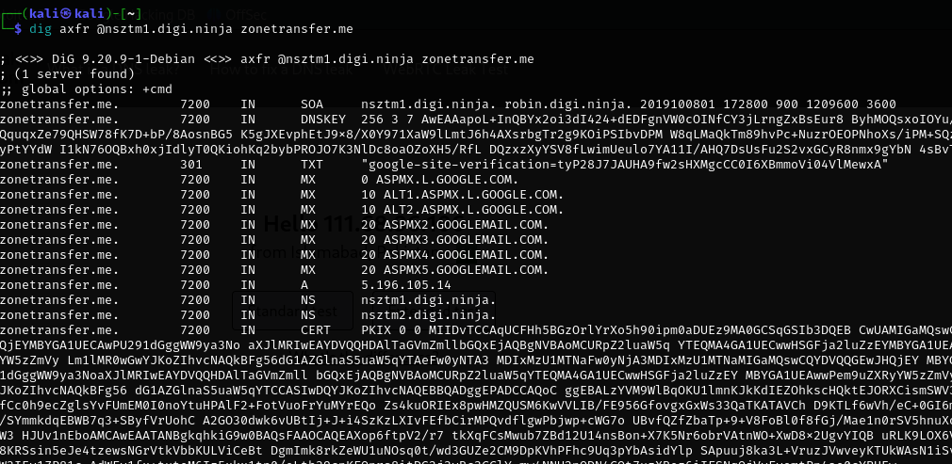

The zonetransfer is not configured on the cloudflare so they cannot be xone transferred.
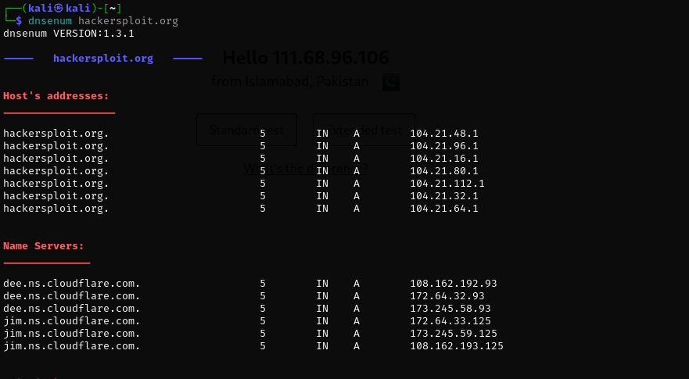
No zonetransfer
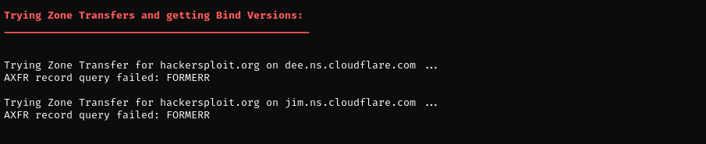

Fierce:
Fierce is a DNS reconnaissance tool used to find subdomains and check for DNS misconfigurations.

✅ In simple words:
Fierce helps you:
- 🔍 Find subdomains of a target (like mail.example.com, ftp.example.com)
- 🌐 Try DNS zone transfers
- 📡 Check for wildcard DNS
- 📘 Perform brute force subdomain enumeration
- 🗂️ Show IPs of domains and subdomains

fierce --domain zonetransfer.me
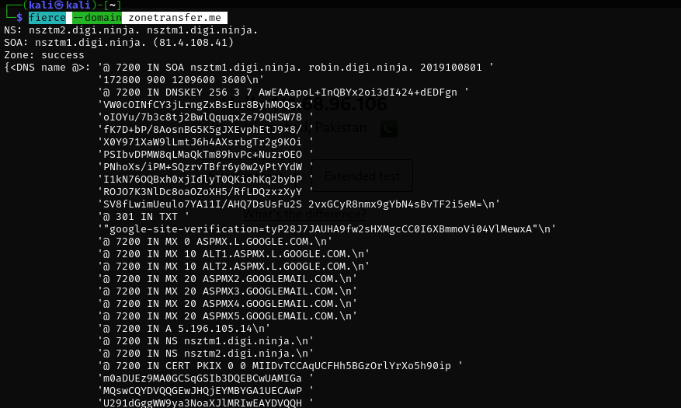
fierce --domain hackersploit.org
